HyperFrames Commercial Video Portfolio
Website / SaaS page / product UI -> premium launch video, demo video, and sales-ready delivery package
This file is for direct sharing with prospects, partners, and internal decision-makers. It shows the five strongest sample directions, what each sample is good for, and how the trial offer is scoped.

What This Service Sells
- Turn a static website, product page, UI screenshot set, or screen recording into a premium product video.
- Use the first paid version as a 20-30 second trial asset for homepage trust, Product Hunt, sales outreach, or investor updates.
- Do not sell software first. Sell the video result first.

1. SaaS UI Demo
Category: SaaS UI callout
What it lets you sell: 把后台界面、仪表盘、功能路径做成高级讲解视频。
Best commercial use: 适合官网功能页、销售 demo、融资材料，让复杂后台在 30 秒内被看懂。
Technique: UI crop, callout annotations, motion hierarchy, dashboard focus choreography.
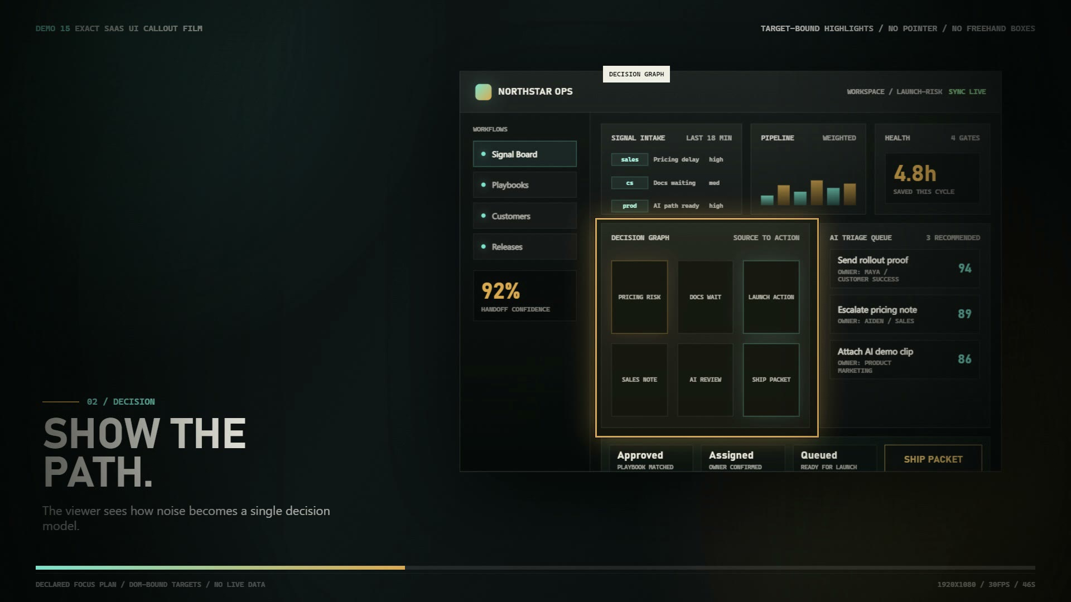
Poster preview
Preview video: saas-ui-demo.mp4
Proof source: hf-exact-saas-ui-callout-proof-review.mp4

2. Screen Focus Demo
Category: screen recording to sales asset
What it lets you sell: 把录屏和屏幕内容变成有重点、有节奏的解释视频。
Best commercial use: 适合产品教程、功能发布、销售邮件，解决普通录屏没有重点的问题。
Technique: Screen capture, spotlight, cursor-style route, zoom and callout sequencing.
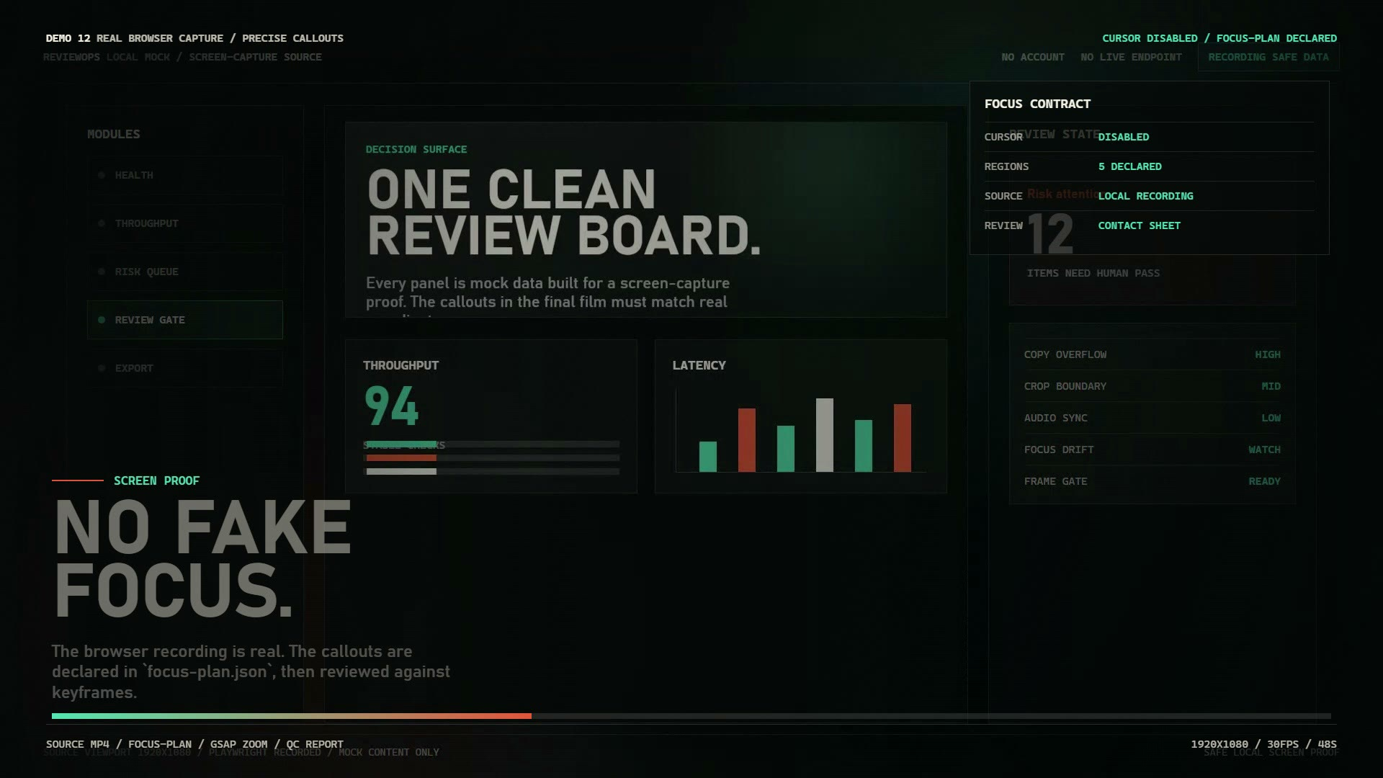
Poster preview
Preview video: screen-focus.mp4
Proof source: hf-screen-callout-proof-review.mp4

3. Website Editorial Film
Category: website to launch video
What it lets you sell: 把真实官网、CTA、页面模块变成 editorial 风格产品宣传片。
Best commercial use: 适合官网首屏视频、Product Hunt 发布、社媒首发，让静态网页变成发布级表达。
Technique: Website capture, editorial framing, kinetic type, page-to-scene recomposition.
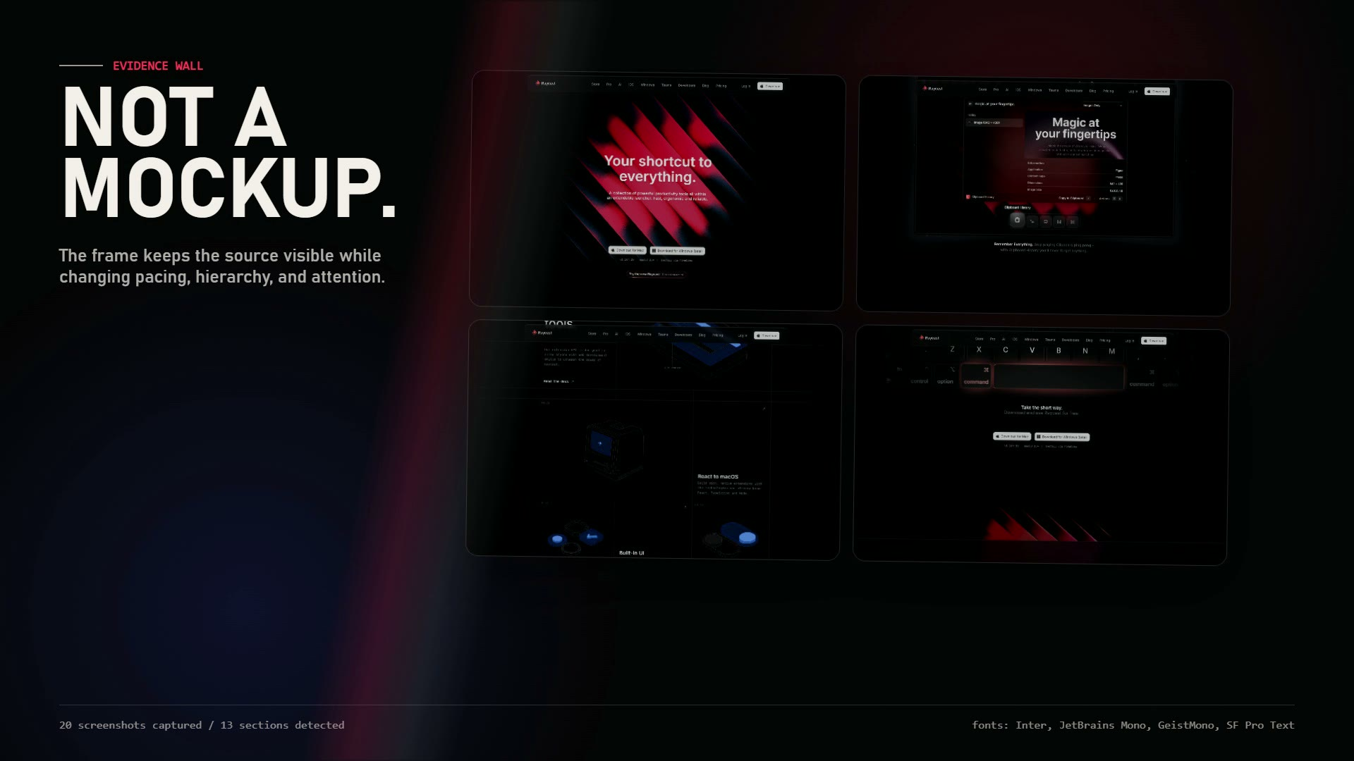
Poster preview
Preview video: website-editorial.mp4
Proof source: hf-real-website-editorial-proof-review.mp4

4. Premium Launch Film
Category: product launch film
What it lets you sell: 把产品卖点、界面、品牌资产做成发布感强的 launch video。
Best commercial use: 适合融资、发布会、Product Hunt、投资人更新，提高产品第一眼质感。
Technique: Launch pacing, product reveal, brand lockup, cinematic typography.
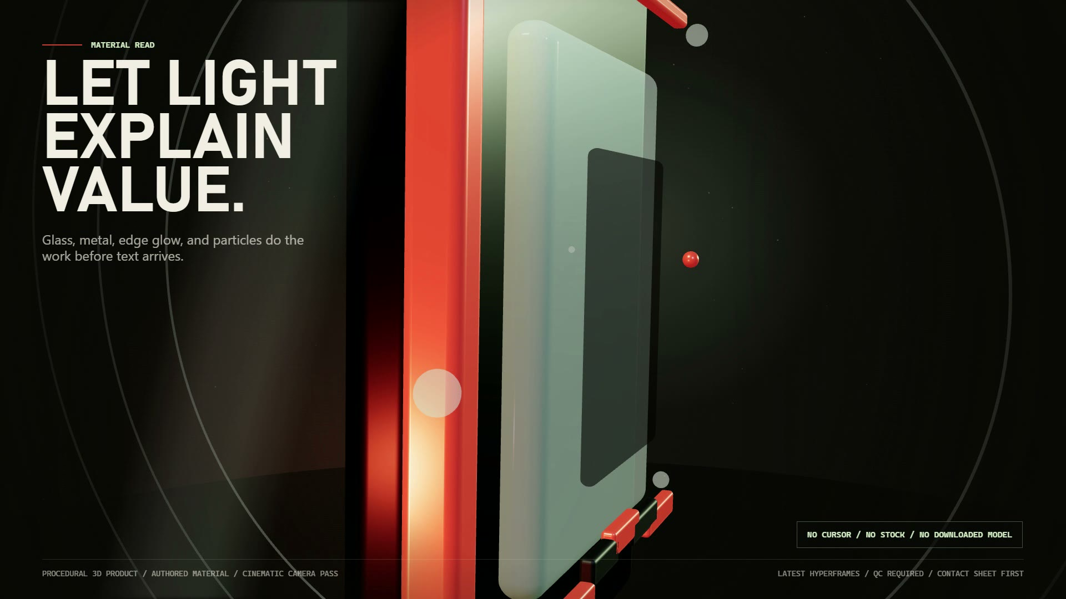
Poster preview
Preview video: launch-film.mp4
Proof source: hf-demo18-premium-product-launch-proof-review.mp4

5. Premium Product Promo
Category: premium product video
What it lets you sell: 把产品图、官网素材和主视觉包装成高端产品宣传片。
Best commercial use: 适合高客单价产品、AI 工具发布、品牌官网，提高感知价值。
Technique: Photographic product staging, material lighting, controlled camera motion.

Poster preview
Preview video: premium-product.mp4
Proof source: hf-demo20-photographic-product-film-proof-review.mp4

Trial And Package Range
Trial: Single Page Short Video
- Price: RMB 1,999-3,999
- Scope: 20-30 seconds, one page or one core feature
- Deliverables: MP4, cover image, script, commercial-use note
- Revision: one light revision
- Best for: first proof, quick Product Hunt/social asset
Standard: Website / SaaS Promo
- Price: RMB 5,999-12,000
- Scope: 30-60 seconds, 3-5 selling points
- Deliverables: main MP4, short cutdown, cover, script, usage notes, QA package
- Revision: one content revision plus one polish pass
- Best for: landing page, sales demo, launch campaign
Launch Pack
- Price: RMB 15,000-30,000
- Scope: 60-second main film, 3 teasers, launch keyframe
- Deliverables: main video, teasers, cover/keyframes, bilingual captions optional, delivery report
- Best for: fundraising, launch day, premium product announcement

What A Prospect Needs To Send
- Product / website URL
- 3-5 selling points
- Target customer
- CTA: book demo, sign up, join waitlist, buy now, contact sales
- Logo and brand colors
- Product screenshots or screen recording
- Any reference video they like
- Where the video will be used: website, sales deck, Product Hunt, X/LinkedIn, ad, investor update
- Deadline and desired duration
Fast reply template:

可以，你先发我这些就够：
1. 官网/产品链接
2. 3-5 个核心卖点
3. 目标用户是谁
4. 希望视频最后让用户做什么动作
5. Logo / 截图 / 录屏，有什么先发什么
我先判断适不适合做，以及最应该做成哪种视频。

Fastest Next Step
Send one of these first: website URL, product page URL, UI screenshots, or a short recording.
Default low-friction CTA: Send me the product page or main UI screen and I can suggest a 20-30 second trial video scope.

